The European institutions.
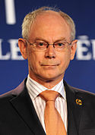
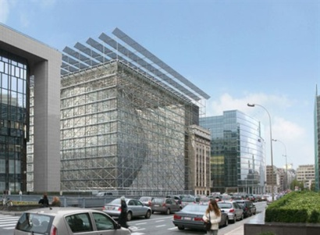
The European Council. It gives......... the EU. It …...................the President of the …............
…........................, the President of the …........................................ and one ….............................. per member state; either its head of state or head of government. It …................. at least …...... times a year, in …............. Since 2009, it has a permanent President, Herman …............. The next summit will be held on October, 17th 2011. (Source : http://www. european-council.europa.eu)
Europa: the new building for the European council in Brussels.

The European Commission. : it …................... legislation and the day-to-day running of the EU. It is composed of ….......................... and represents the …...................... dimension of the Union. Its Vice-President, Catherine ….......... is also the ….............................................................................
…....................................... Its President, José Manuel …............., has been appointed by the ….............................. (Source : http://ec.europa.eu/)

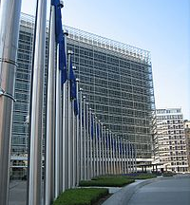
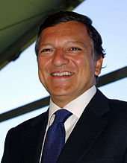

The Berlaymont, headquarters in. Brussels.

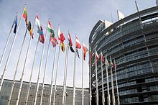


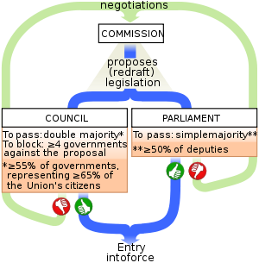
The European Parliament: it forms …....... of the EU …...................... It is composed of …....... MEPs elected by ….................... suffrage every …........ years (last transnational elections, held in …..........; next in ….......). …................. sessions are held in ….............., but ….............................................. meet in …..................., while the Secretariat is located in …..........................(Source : http://www. europarl.europa.eu
TheCouncil of the European Union (or Council of Ministers) meets in …....................
…......... depending on the …............................... being addressed. It shares the ….
…................. power with the European Parliament. It is currently chaired by the …............... repre-sentatives. It is located in …........... (Source : http://www. consilium.europa.eu

