Arab-Israeli Wars: 1947/1949 – 1973.
Script of the Quiz.
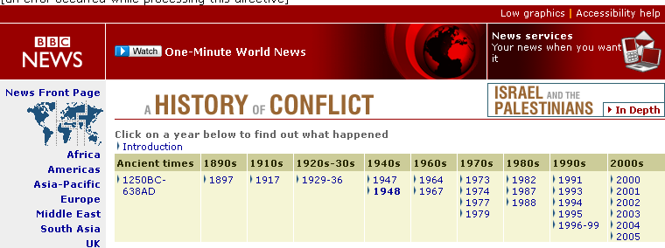
In italics – BBC quotations
(http://news.bbc.co.uk/2/shared/spl/hi/middle_east/03/v3_ip_timeline/html/1947.stm)

1948-1949 – the First Arab-Israeli War & the “naqba” (Arabic for “catastrophe”). In 1947, Palestine – which had been up until then a British mandate – was divided between Jews and Arabs according to a UN partition plan. A first Israeli-Arab conflict broke out in 1948-1949.
“The day after the state of Israel was declared ………………. armies from ………………., ………………., ………………., ………………., and ………… immediately ………………. but were repulsed, and the Israeli army crushed pockets of resistance. Armistice established …………………………… on the frontier of most of the earlier British Mandate Palestine. Egypt kept the ………………….. while ………………. annexed the area around East Jerusalem and the land now known as the West Bank. These territories made up about 25% of the total area of British Mandate Palestine.”
More than 700 000 "Israeli Arabs" fled from their towns and villages in the area that was to become the State of Israel.

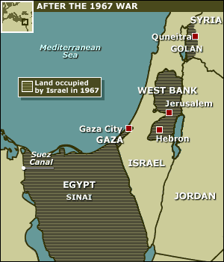
1956 – The Second Arab-Israeli War : the Suez crisis. Tensions mounted again with the rise to power of Egyptian President Gamal Abdel Nasser, a Pan-Arab nationalist. In 1956 Nasser nationalized the Suez Canal, a vital waterway connecting Europe and Asia that was largely owned by French and British concerns. France and Britain responded by striking a deal with Israel wherein Israel would invade Egypt; France and Britain would then intervene, ostensibly as peacemakers, and take control of the canal. War broke out – as laid down by the 3 countries – but the USA and the USSR compelled the warring sides to stop fighting in order to preserve peace in the Middle East.

1967 – The Third Arab-Israeli War : The Six-Day War. “Mounting tensions between Israel and its …………………… culminated in ……………….of hostilities in ……... Israel seized ………… and the …………… from Egypt in the south and the ………………….. from Syria in the north. It also pushed Jordanian forces out of the …………………. and …………………. The territorial gains doubled the area of land controlled by Israel. The conflict displaced another 500,000 Palestinians who fled to Egypt, Syria, Lebanon and Jordan.
The UN Security Council called for the “…………………. of Israeli armed forces from territories ………………. in the recent conflict.”

1973 - The Fourth Arab-Israelli War : the 1973 Yom Kippur war. “Unable to regain the territory they had lost in 1967 by diplomatic means, ………. and ……………….launched major offensives against Israel on the Jewish festival of the Day of ………………. or Yom Kippur. Initially, Egypt and Syria made ………………. in Sinai and the ……………….Heights. These were ……………….after three weeks of fighting. Israel eventually made gains beyond the 1967 ………………. lines.”
Egypt negotiated a peace agreement with Israel and got back full control over the Sinai and the Suez canal. The PLO (for Palestine Liberation Organisation), led by Yasser Arafat, and backed by the USSR, asked for the creation of an independent state. It also advocated for guerrilla warfare against Israel.

1974 - Arafat's first UN appearance and first quest for peace.
PLO factions attacked Israeli athlets at the Munich Olympics in 1972. They killes 11 Israeli athlets! This deeply chocked the international community. In 1974, Yasser Arafat promoted more peaceful solutions to be recognised by the UN (1974).
Arafat then concluded: "Today I have come bearing an olive branch and a freedom fighter's gun. Do not let the olive branch fall from my hand." The speech was a watershed in the Palestinians' search for international recognition of their cause.”
Between 1975 and 1990, violence shifted to Southern Lebanon which served as rear base for many PLO resistance fighters. The Israeli military intervention brought about that of Syria to “protect” – or invade- Lebanon…

1987 – First Palestinian ‘intifada’
“A mass uprising - or intifada - against the Israeli occupation began in Gaza and quickly spread to the West Bank. Protest took the form of civil disobedience, general strikes, boycotts on Israeli products, graffiti, and barricades, but it was the stone-throwing demonstrations against the heavily-armed occupation troops that captured international attention. The Israeli Defence Forces responded and there was heavy loss of life among Palestinian civilians. More than 1,000 died in clashes which lasted until 1993.” (BBC News).

