
Homework 1 - Europe : Physical geography

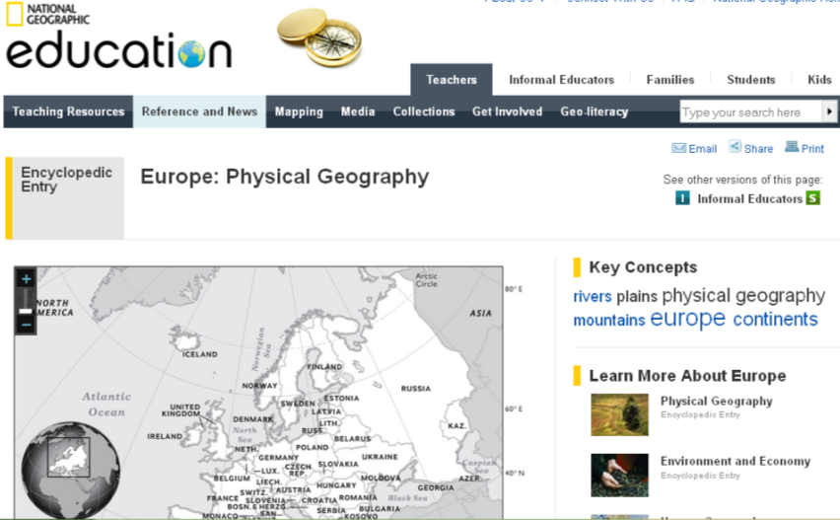
Use National Geographic Society online resources to fill in the blanks in the text below. (Introduction + one out of the 4 physical regions + Glora & Fauna)
Type “National Geographic” + “Europe:physical Geography” and make sure you get the right page (cf. screenshot from http://education.nationalgeographic.com/education/encyclopedia/europe-physical-geography?ar_a=1)

(Introduction) « Europe is the ………………………………………….. Only Oceania has less……………………….. Europe extends ………………………………….. the west …………. ……………………………….. of Russia in the east.
Europe is sometimes described as a ……………………………………………………A peninsula is a piece of land surrounded by water on three sides. Europe is a peninsula of the ……………………………………………………and is bordered by the Arctic Ocean …… the north, the Atlantic Ocean to the west, and the ………………………………………………… Seas to the south. (...)

Europe can be divided into ……………………………………………………., running from north to south: Western Uplands, North European Plain, Central Uplands, and Alpine Mountains.

- Western ………………………………..
The Western Uplands, also known as the …………………………………., curve up the …………………………….e of Europe and define the physical landscape of ………………………. and of the ………………………… of Western Europe.The Western Uplands is defined by hard, ancient …………………… that was shaped by ……………………….. As …………….. receded from the area, they left a number of distinct physical features, including abundant ……………………………………………………………...

2. North European Plain
The …………………………………….. extends from the southern United Kingdom east to Russia.
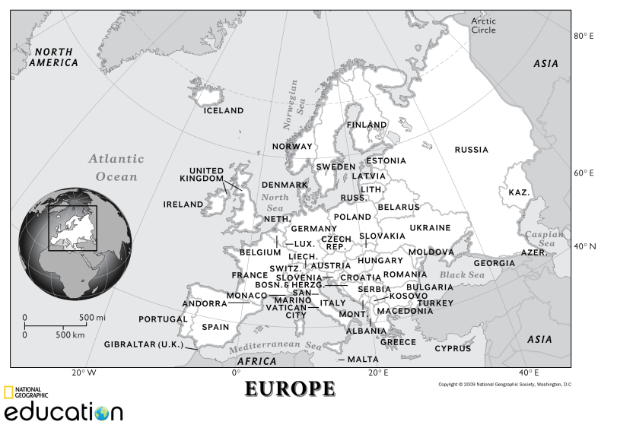
Most of the Great European Plain …………………………….. (500 feet) in elevation. It is ……………………… many navigable rivers, including the ……………………………………. …………………………………. The North European Plain remains the most densely populated region of Europe.

3. Central Uplands
The …………………………. extend ……………………………….. Europe and include western France and Belgium, southern Germany, the ………………………….., etc. The Central Uplands are …………………………………………………………. than the Alpine region and are heavily ……………………………. This region is ……………………….. populated except in the Rhine, Rhone, Elbe, and Danube river valleys.

4. Alpine Mountains
The Alpine Mountains include …………………… in the Italian and ………………… peninsulas, northern Spain, and southern France. The region includes the mountains of the ……………………………………………………………………………………. High elevations, …………………………….., and …………………………………. land define the region.

Flora & Fauna
Much like its physical regions, Europe’s plant and animal communities follow a general …………………………………… The …………………….., found in Iceland and the northern reaches of Scandinavia and Russia, is a ……………………. region where small ………… ……………………………………grow. Huge …………………………. feed on these tiny plants.
……………………………, which stretches across northern Europe just south of the tundra, is composed of coniferous forests, with trees such as …………………….. ……… …………………………………..are native to the European taiga.
Just south of the taiga is a …………………………………… …………………. trees (# evergreen), including beech, ash, poplar, and willow. Although this area remains heavily forested, the continents forests were …………………………….. as a result of intense urbanization throughout human history. Intense trade introduced many species, which often overtook native plants. The ……………………………………………. of western and central Europe have been almost completely domesticated, with ………………………………… dominant.
Finally, small, …………………………….. plants …………………………………….. Sea, Europes southern edge. Trees also grow in that southernmost region, including the Aleppo pine, cypress, and cork oak. (...).

