Palestine at the heart of the Arab-Israeli conflicts since 1947.
HIST
ORY

Introduction.
No issue has engaged the attention of the international community over the past half century or more as much as what is known as the “Question of Palestine”, or in other words the “Arab-Israeli conflicts”. How can we explain this enduring and explosive conflict?
Lesson plan.
- Two peoples, one land.  1 a. A crossroads for different civilisations  1 b. Three times a holy land.  1 c. Cultural heritage as a matter of conflict. | - The Arab-Israeli conflicts.  2 a. Palestine as a geopolitical flashpoint.  2 b. Peace process stalled.  3 b. Political divisions and obstacles.
- Current obstacles to peace.
3 a. The question of borders and security 3 b. Israeli settlements
3 c. Jerusalem, crucible of all conflicts 3 d Palestinian refugees’ right to return home.
3 e. Water issues in Palestine.

Timeline. 19 BCE – 2nd Temple rebuilt by King Herod – 63 BCE – Pompeius conquered Palestine. 33 AD – crucifixion of Jesus (according to religious sources) – 70 AD – destruction of the Temple by Titus – 4th to 7th c. Byzantine rule (Church of the Holy Sepulchre) – 638: Jerusalem conquered by the Umayyad califs (Dome of the Rock, Al-Aqsa mosque) – 11th-12th c. Christian Crusader States – 1187 : Jerusalem conquered by Saladin, an Ayyubid prince – 1917 – 1948 : Palestine became a British Mandate, entrusted by the League of Nations – 1948-1967 : Jordan rule over Old Jerusalem and East Jerusalem. 1967 – Jerusalem conqured by the Israelis. 1980 : annexation of East Jerusalem by Israel.
Vocabulary
A crossroads for different civilisations – the Holy City – a thrice Holy City – to worship – a place of worship – Nabuchadnezzar – King Herod - the Crusaders – the Umayyad caliphs – the Mammeluk – the Ottomans – a mandate – the League of Nations – to conquer – to annex – an annexation – to occupy a country – a settlement policy – a fence – the Arab - Israeli wars – the Israeli-Palestinian conflict – an international border - archaeological excavations – artefacts – archaeological remains- a World Heritage site – a disputed land – a Diaspora.
Three times a Holy Place – the Temple Mount – Old Jerusalem – the Western wall (or Wailing wall); the Noble Sanctuary (the Dome of the Rock – Al-Aqsa mosque) – The Church of the Holy Sepulchre, the Via Dolorosa.
Landmarks – The Middle east (the Near east) – Lebanon – Syria – Palestine – Israel – Jordan – the Jordan river - Jerusalem – Old Jerusalem – East Jerusalem – the Gaza Strip – the West Bank – the West Bank Barrier – the Golan Heights – the Sinai peninsula.
About Judaism - Torah scrolls - Holy Covenant – a bimah – a menorah – the Eternal Light - The Ark - The Star of David - The Lions of Judah – a rabbi - Sephardic Jews – Ashkenazim – orthodox/liberal Jews – a synagogue – Yahweh – an Abrahamic monotheism – Moses.
About Christianity - the Old Testament - the New Testament – crucifixion – Salvation – redeeming – sins – the pope a parish – a priest - the Orthodox church – a patriarch – protestant churches (Lutherians, Calvinist, Methodists, Pentecostalists, etc.) – a minister – a tall spire – the Waqf.
About Islam – mosque – a gilded dome – a minaret – a mihrab – the qiblah – a minbar – a prayer hall - an imam – the Koran (or Qu’ran) – Allah – a prophet - the Sunnah – Sunni Islam – the Sunnis (or Sunnites) – Shia Islam - the Shias – the Mecca – Isa – a pilgrimage – to fast.

INTERACTIVE maps & timelines on the web.
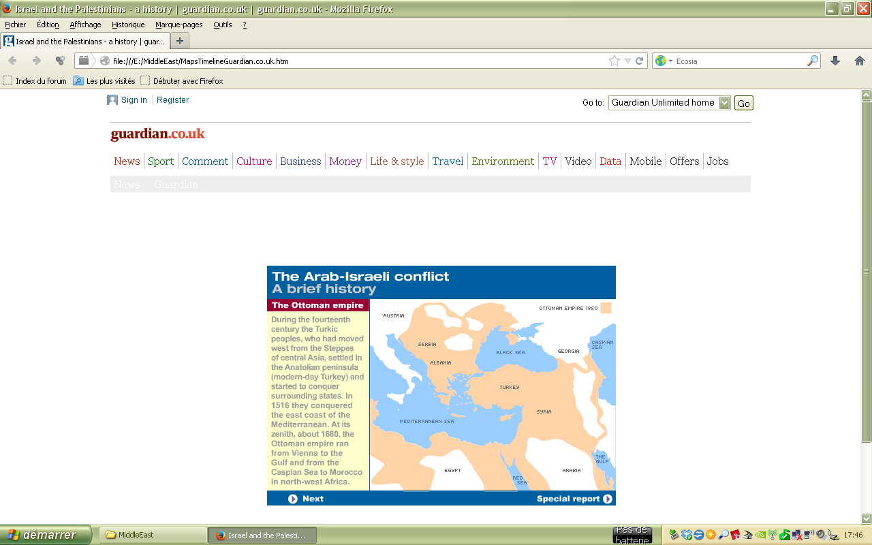
Israel and the Palestinians - a history | guardian.co.uk 2011
theguardian.com/flash/0,5860,720353,00.html

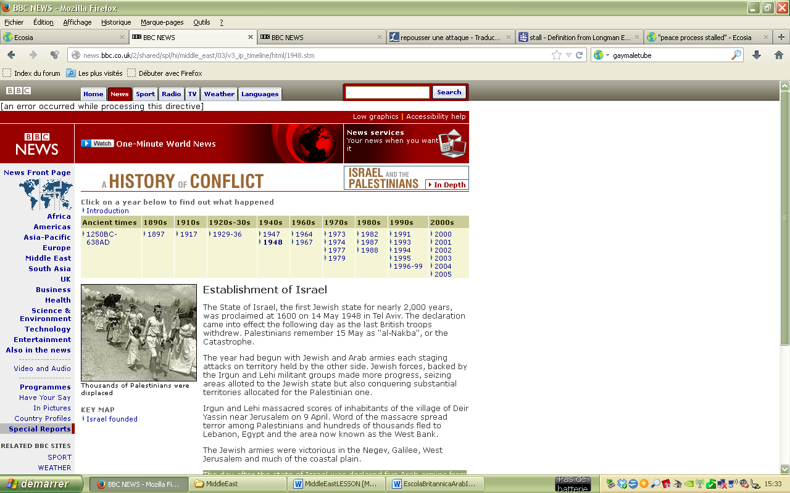
BBC News – a history of Conflict
http://news.bbc.co.uk/2/shared/spl/hi/middle_east/03/v3_ip_timeline/html/1917.stm

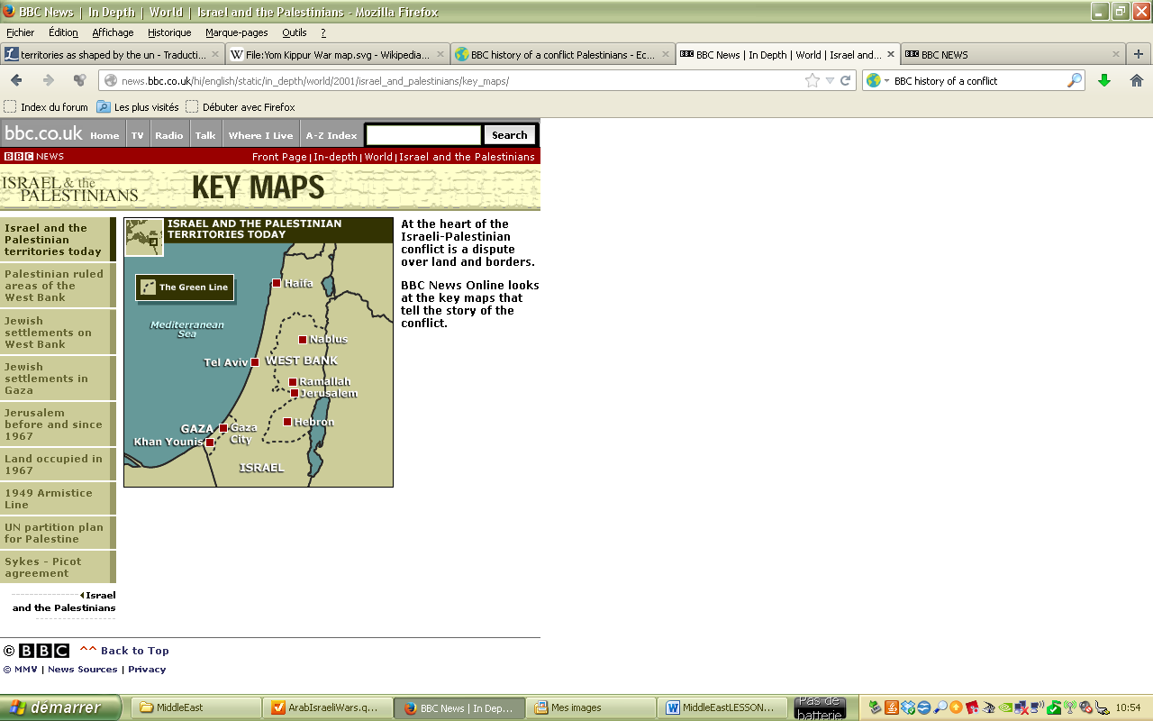
BBC News IN DEPTH – Israel & the Palestinians.
At the heart of the Israeli-Palestinian conflict is a dispute over land and borders. BBC News Online looks at the key maps that tell the story of the conflict.
http://news.bbc.co.uk/hi/english/static/in_depth/world/2001/israel_and_palestinians/key_maps/
Palestine at the heart of the Arab-Israeli conflicts since 1947.
HIST
ORY

INTRODUCTION.
No issue has engaged the attention of the international community over the past half century or more as much as what is known as the “Question of Palestine”, or in other words the “Arab-Israeli conflict”.
A major issue consists in the conflicting claims of the Jews and Arabs to Palestine, a region of the Middle East that includes the Holy Land sacred in Judaism, Islam, and Christianity.
- For the Jewish people of Israel, the return to the land of their forefathers after centuries of persecution around the world has not brought peace or security. They have faced many crises as their neighbours have sought to wipe their country off the map.
- But for Arab Palestinians the last 100 years have brought colonisation, expulsion and military occupation, followed by a long and difficult search for self-determination and for coexistence with the nation they hold responsible for their suffering and loss.

From 1947/48 up to now, tensions between the two nations have brought about a series of long, seemingly endless wars.

Key questions:
Why has it become one of the most enduring and explosive of all the world's conflicts? What reasons may account for these continual fightings?

- Two peoples, one land.

Palestine has been promised twice or eve three times… but to different peoples!

1 a. A crossroads for different civilisations

Exercise 1 : Jerusalem history – timeline

According to the Hebrew Bible, King David of Israel first established Jerusalem as the capital of the united kingdom of Israel by 1000 BCE, and his son Solomon commissioned the building of the First Temple in the city (which eventually was destroyed by the Babylonians). It was where Herod the Great ('Great' because of his buildings) constructed, or re-constructed, the Second Temple by 19 BCE.
The Romans knew Jerusalem as a place of Jewish rebellion and, under Titus, demolished it in 70 AD (the Common Era) after the Zealots' revolt, which also saw the siege and fall of Masada.
After the Roman Empire developed into the Byzantine, the Temple Mount lay largely empty for centuries. Christians were more interested in the site of Jesus' crucifixion.
But in 638, the Muslim army of Omar, Commander of the Faithful, conquered Jerusalem. There was then built one of the most beautiful edifices in the world, the Dome of the Rock, followed by the al-Aqsa mosque nearby.
The Crusades allowed Western countries, alongside with the Roman Catholic Church, to establish Crusader states during the 12th and 13th centuries.
Palestine was then conquered again by Muslim rulers, especially the Ottomans from 1516 to 1917.
Mandates were territories whose administration was entrusted to European colonial powers by the League of Nations after WW1 to help these territories prepare for their independence.
It became a British Mandate, entrusted by the League of Nations from 1917 to 1947.

The French & British control over the Middle East broght about deep changes.

Exercise 2 – History of the Arab-Israeli conflict on the BBC (
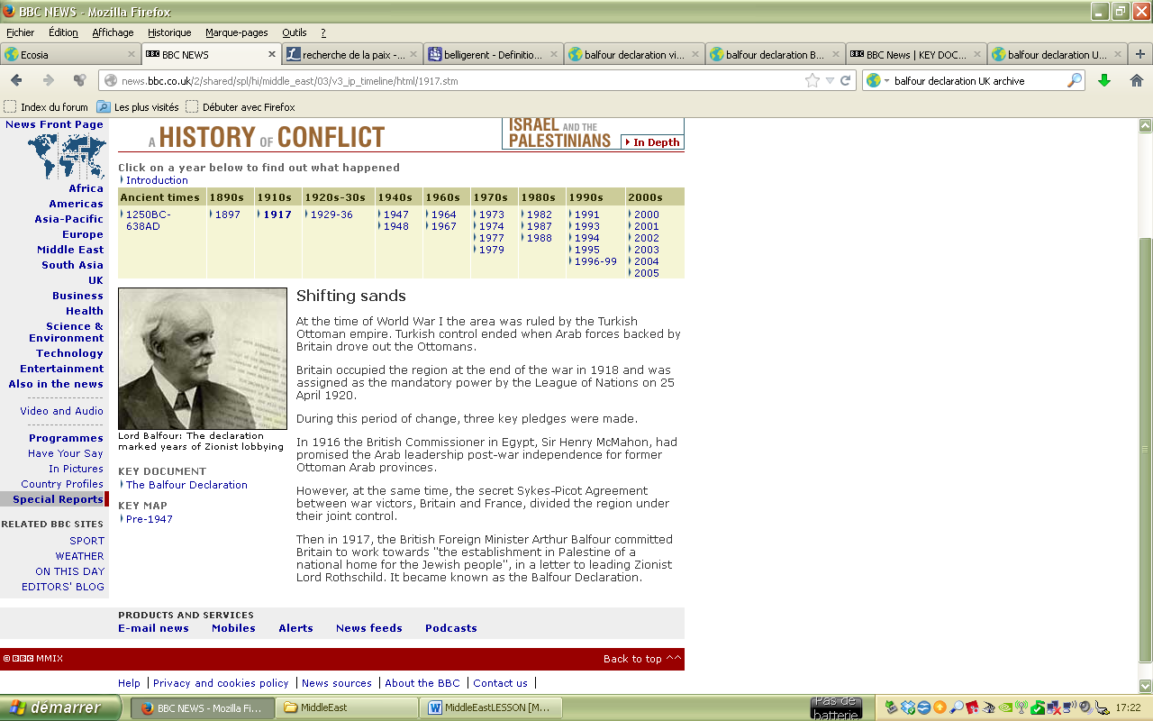
1917 – Lord BALFOUR’s Declaration : cf BBC
“During this period of change, three key pledges were made.
In 1916 the British Commissioner in Egypt, Sir Henry McMahon, had promised the Arab leadership post-war independence for former Ottoman Arab provinces.
However, at the same time, the secret Sykes-Picot Agreement between war victors, Britain and France, divided the region under their joint control.
Then in 1917, the British Foreign Minister Arthur Balfour committed Britain to work towards "the establishment in Palestine of a national home for the Jewish people", in a letter to leading Zionist Lord Rothschild. It became known as the Balfour Declaration.”

1929-1936 - Arab discontent
“The Zionist project of the 1920s and 1930s saw hundreds of thousands of Jews emigrating to British Mandate Palestine, provoking unrest in the Arab community.(…)
Zionist-Arab antagonism boiled over into violent clashes in August 1929 when 133 Jews were killed by Palestinians and 110 Palestinians died at the hands of the British police.(…)
Palestinian and Arab representatives demanded an end to immigration and the safeguarding of a single unified state with protection of minority rights. Violent opposition continued until 1938 when it was crushed with reinforcements from the UK.”

1 b. Three times a holy land.
- What is the religious significance of Jerusalem to each civilisation?

Cf. slideshow about Jerusalem.

In Judaism, Palestine has been considered a Promised Land given to Jews by their God Yahweh. Jerusalem is home to the rock on which Abraham offered his son as a sacrifice.
Videos : Presentation Palestine

For the Jews, it was once the centre of their world - and the place to which they always promised themselves in exile that they would return. Even today, Jews pray at the nearest point they can reach to the Temple Mount, its Western Wall, once known as the Wailing Wall.
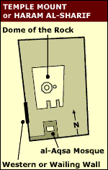
According to Jewish Law, one is obligated to grieve and rend one's garment* upon [:while] visiting the Western Wall and seeing the desolate site of the Temple. Hence its name… [to rend = to tear into pieces]. Jews are mourning the destruction of the Temple as if it signified that Yahweh had broken the Covenant [:sacred Alliance] he sealed with its Chosen People…
For religious Jews, the Mount is where redemption will take place when the Messiah arrives. As the Mount itself is forfidden to Jewish prayers, the Western wall is arguably the most sacred site recognized by the Jewish faith outside of the Temple Mount itself.
Saint Helena or Helena of Constantinople (ca. 246/50 – 18 August 330) was the mother of Emperor Constantine the Great. She is traditionally credited with finding the relics of the True Cross.
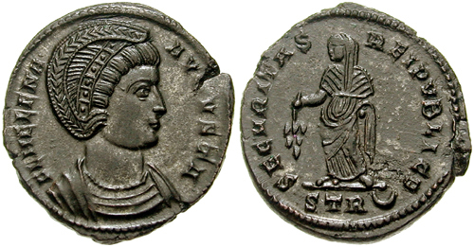
- In Christianity, Jerusalem has been a holy city since, according to the New Testament, Jesus was crucified there and rose again from the dead. 300 years later Saint Helena identified the pilgrimage sites of Jesus' life, like the Church of the Holy Sepulchre (believed to be the site of the crucifixion of Jesus Christ), the Church of John the Baptist and the Via Dolorosa (“Way of Grief" or "Way of Suffering", a street, in two parts, within the Old City of Jerusalem, held to be the path that Jesus walked, carrying his cross, on the way to his crucifixion).
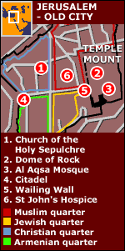
- In Sunni Islam, Jerusalem is the third-holiest city. It became the first Qibla, the focal point for Muslim prayer in 610 CE.
The Dome became, in Muslim eyes, holy because they believe that it was from this rocky outcrop that the Prophet Muhammad in a night journey ascended into heaven on his horse Buraq to receive commandments from God.
Popular Islamic tradition speaks of the Prophet being taken from Makkah to Jerusalem on a winged horse and then being lifted to heaven where he was shown by God when and how to pray. The al-Aqsa ("The Furthest") was built to commemorate the furthest mosque to which Muhammad states that he travelled from Mecca in his dream. It has become the third most holy place in Islam, after Mecca and Medina.
The Temple Mount is thus known to Muslims as the Haram al-Sharif, or the Noble Sanctuary. The plot contains the Dome of the Rock, and the al-Aqsa Mosque - Islam's third holiest site.

As a result, the Old City of Jerusalem is home to many sites of tremendous religious importance, among them the Temple Mount, the Western Wall, the Church of the Holy Sepulchre, the Dome of the Rock and al-Aqsa Mosque.

1 c. Cultural heritage as a matter of conflict.
Cultural heritage is often a matter of conflict.
Due to the extreme religious and political sensitivity of the site, few archaeological excavations have been conducted on the Temple Mount itself. Protests commonly occur whenever archaeologists conduct projects on or near the Mount.
Since Israel took over control of the Old City in 1967, archaeological excavations in the vicinity of the Mount have been undertaken by Israel and the Waqf. Both excavations have been controversial and criticized. Israeli excavations have also sparked demonstrations and objections in the Muslim world. Israeli and Jewish groups have criticized excavations conducted by the Waqf, the Muslim authority in charge of the Al-Aqsa Mosque.

Two examples: excavations at Temple Mount - The Western Wall Tunnel.
1996 - After the Six Day War (1967), Israel began the excavations aimed at exposing the continuation of the Western Wall. The excavations lasted almost twenty years and resulted in a 500 m tunnel – called the Western Wall Tunne - near the Temple Mount. It was opened to the public in 1996. Fueled by the allegation that the tunnel would undermine the Temple Mount, Palestinians protested. Consequently, gun battles in the West Bank and Gaza Strip killed 54 Palestinians and 14 Israeli soldiers.

2000: Ariel Sharon’s 'Provocative' mosque visit sparks riots. The visit was clearly intended to underline the Jewish claim to the city of Jerusalem and its holy sites. Violence again broke out throughout Jerusalem and the West Bank. It was the beginning of a wave of rioting which escalated into what is now known as the second Palestinian intifada (uprising).
By the end of the first year, more than 800 people had died.

- The Arab-Israeli conflicts.
2 a. Palestine as a geopolitical flashpoint.
BBC History of the conflict
Cf. exercise + correction (no notes required here!!). In italics – BBC quotations

1948-1949 – the First Arab-Israeli War and “Al naqba” (Arabic for “catastrophe”). In 1947, Palestine – which had been up until then a British mandate – was divided between Jews and Arabs according to a UN partition plan. A first Israeli-Arab conflict broke out in 1948-1949.

1956 – The Suez crisis. Tensions mounted again with the rise to power of Egyptian President Gamal Abdel Nasser, a Pan-Arab nationalist. In 1956 Nasser nationalized the Suez Canal, a vital waterway connecting Europe and Asia that was largely owned by French and British concerns.

1967 – The Six-Day War. Israel’s “territorial gains doubled the area of land controlled by Israel. The conflict displaced another 500,000 Palestinians who fled to Egypt, Syria, Lebanon and Jordan. The UN Security Council called for the "withdrawal of Israeli armed forces from territories occupied in the recent conflict.”

1973 - The 1973 Yom Kippur war.
Egypt negotiated a peace agreement with Israel and got back full control over the Sinai and the Suez canal. The PLO (for Palestine Liberation Organisation), led by Yasser Arafat, and backed by the USSR, asked for the creation of an independent state. It also advocated for guerrilla warfare against Israel.

1974 - Arafat's first UN appearance and first quest for peace.
“PLO factions and other militant Palestinian groups [attacked Israelis] at the Munich Olympics in 1972 in which 11 Israeli athletes were killed.” This deeply chocked the international community. “In 1974, Arafat made a dramatic first appearance at the United Nations mooting a peaceful solution: "Today I have come bearing an olive branch and a freedom fighter's gun. Do not let the olive branch fall from my hand." The speech was a watershed in the Palestinians' search for international recognition of their cause.”
Between 1975 and 1990, violence shifted to Southern Lebanon which served as rear base for many PLO resistance fighters. The Israeli military intervention brought about that of Syria to protect Lebanon…

1987 – First Palestinian ‘intifada’
“A mass uprising - or intifada - against the Israeli occupation began in Gaza and quickly spread to the West Bank. Protest took the form of civil disobedience, general strikes, boycotts on Israeli products, graffiti, and barricades, but it was the stone-throwing demonstrations against the heavily-armed occupation troops that captured international attention.”
2 b. Peace process stalled.
International pressure caused the two sides to make concessions: in 1988, the PLO recognised the state of Israel and the end of the Cols War enabled the USA to encurage Israel to start negotiations. In 1993, the peace process was initiated.

1993 – The Oslo Peace Process
The Oslo accords are the foundation on which peace negotiations between Israel and the Palestinians are based. Officially called the "Declaration of Principles," the accords were negotiated secretly by Israeli and Palestinian delegations in 1993 in Oslo, Norway. It was signed in a historic Washington ceremony hosted by President Bill Clinton on September 13, 1993, during which PLO chairman Yasser Arafat and Israeli Prime Minister Yitzhak Rabin grasped hands in an uneasy, yet unforgettable handshake.
The agreement involved mutual recognition and envisaged the gradual withrawal of Israeli troops from the West Bank and Gaza Strip, leading to the gradual implementation of Palestinian self-government in these territories, as a condition for permanent peace settlement.
Unfortunately, these agreements have not been fulfilled by any of the two partie in conflict. The situation quickly worsened after the Oslo Accords: Yitzhac Rabin – the Israeli Prime Minister who symbolised Israeli concessions to peace – was assassinated by a right-wing Israeli radical, and a new but more radical Intifada broke out, involving terrorist attacks against Israeli cvilians and security forces. Peace was still a long way off!

1996-1999 - Deadlock
“Conflict returned early in 1996 with a series of devastating suicide bombings in Israel carried out by the Islamic militant group Hamas, and a bloody three-week bombardment of Lebanon by Israel.
Peres narrowly lost elections on 29 May to the right-wing Binyamin "Bibi" Netanyahu, who campaigned against the Oslo peace deals under the motto "Peace with Security".
The situation worsened again when Israeli governement led by the conservative and rightist Ariel Sharon decided to erect a wall to separate the west Bank from Israel Even though Israel withdrew its troops from the Gaza Strip, violence continues, all the more so as the economic situation of the Palestinians is desastrous. In 2007 the Hamas, a radical Islamist movement which aims at destroying the State of Israel, came to power in the Gaza Strip. Once again, the peace process seems to have ended in a dreadlock.

3 b. Political divisions and obstacles (see exercise)

[In Palestinian Territories] The Palestinians are divided politically between the West Bank-based Fatah (with Mahmoud Abbas) and Islamist Hamas movement, which has controlled the Gaza Strip since 2007, and has condemned the talks.
Some other Palestinian groups, such as the Popular Front for the Liberation of Palestine (PFLP – a revolutionary leftist but terrorist organisation), staged protests against any Peace talks. The PFLP is well known for pioneering armed aircraft hijackings in the late '60s and early '70s.

[In Israel], Mr Netanyahu (Likud) also faces internal challenges. Despite the public support for peace talks, some of his coalition partners - for example the Jewish Home party – - a far-right, ultra-nationalist, and religious orthodox political party - and members of his own Likud party oppose the establishment of a Palestinian state.

[What political perspectives for peace?] Any peace agreement should refer to the UN Resolution 242 which was passed on 22 November 1967 and embodies the principle that has guided most of the subsequent peace plans - the exchange of land for peace.
UN resolution 242 - The resolution called for the "withdrawal of Israeli armed forces from territories occupied in the recent conflict", and "respect for and acknowledgement of the sovereignty, territorial integrity and political independence of every state in the area and their right to live in peace within secure and recognised boundaries free from threats or acts of force".
In 2003, 4 powers (making up the so-called Quartet) - the United States, Russia, the European Union and the United Nations – proposed a roadmap to peace, both a timetable and a reference point ot negtiations. A further step was reached the same year in Geneva were it was said that an agreement should be reached first, which was then designed to produce security and peace (Geneva Accord, 2003).

Its main compromise is that the Palestinians effectively give up their "right of return" in exchange for almost the whole of the West Bank, though there could be a token return by a few. Israel would give up some major settlements such as Ariel, but keep others closer to the border, with swaps of land in Israel for any taken in the West Bank. Palestinians would have the right to have their capital in East Jerusalem, though with Israeli sovereignty over the Western Wall in the Old City.

- Current obstacles to peace. See exercises

3 a. The question of borders and security. (see Exercise)
A two-state solution based on the 1967 ceasefire lines implies an Israeli withdrawal from parts of the West Bank (captured by Israel in 1967). Israel has already withdrawn its troops and settlers from Gaza but would like the borders to include the major Israeli settlements that have grown up on the West Bank and Jerusalem. The USA and the Palestinians agree that any land given to the Israelis would have to be compensated for by a balanced land swap.
[Security issues] The Israeli government is also afraid that a Palestinian state might one day fall into the hands of Hamas or be used to attack Israel. Therefore it is insisting that it keeps a large measure of security control, including in the Jordan Valley, and that a state of Palestine be largely demilitarised.

3 b. Israeli settlements (see Exercise).
Ideally, the Palestinians would like all settlements to be abandoned as they were in Gaza. However, they appear to accept that some will have to stay but they will argue for a minimum number and a land swap for any that are left.
The Israeli government has previously insisted on keeping the major Israeli settlements in East Jerusalem and the West Bank.

3 c. Jerusalem, crucible of all conflicts (see Exercise).
The Israeli government is unwilling to divide Jerusalem, held to be the political and religious centre of the Jewish people. It stands by the 1980 Israeli Basic Law that "Jerusalem, complete and united, is the capital of Israel". But this policy has been condemned by the USA and the international community!
The Palestinians want East Jerusalem, which was occupied by Jordan before being captured by the Israelis in 1967, as the capital of a Palestinian state.

3 d Palestinian refugees’ right to return home (see Exercise).
Israel rejects the idea that Palestinian refugees from previous wars should be allowed any "right of return" to their former homes. They say that this is a device to destroy the state of Israel by demography in order to establish a unitary state of Palestine.
Palestinians agree that this "right" could be met by compensation, but they refuse to recognise the concept of Israel as a "Jewish state", saying that this is unnecessary and that it ignores the Israeli-Arab citizens of Israel.

3 d. Water issues in Palestine (see Exercise).
The local water resources originate from the Jordan river, the Tiberiad Lake, as well as a vast mountenous aquiferous sheet almost entirely situated in the West Bank. The occupation of the Palestinian territories of the West Bank and Gaza from 1967 has enabled Israël to meet its increasing water needs for its economic development and for its colonisation policy.
Since 1967, Israel has elaborated a rigorous legislation limiting the right of the Arab in using the waters of the Occuppied Territories (rigorous restrictions with regards to forage, strict quotas…). Since then, water has become a “strategic resource under military control”.
Israel’s economic development is based on an extensive use of the water resources at its disposal: Israel and the Jewish settlements use approximately 81% of this water, leaving only 19% of it to the Palestinians of the West Bank. The excessive exploitation by Israel of this aquifer sheet situated in the West Bank – which covers by itself one third of its water needs – is leading to the irreversible impoverishment and pollution of the Palestinian water reserves.
Only 5% of the lands exploited by the Palestinians are irrigated, as opposed to 69% for the Israeli settlers even though agriculture accounts for more than 30% of the Palestinian GDP as opposed to 5% only of the Israeli GDP. The situation has become even more imbalanced since 1987.
The water question should however be discussed – as foreseen by the Declaration of Principles signed in September 1993 by the PLO and Israel (see « Oslo peace process « ) -in the context of the negociations on the final status of the Palestinian territories.
But the control of these resources remains a priority for Israel.
(Source: http://www.medea.be/en/themes/geopolitics/water-palestine/ )

Conclusion.
The Two-State solution has made its way in all minds, and only extremists from both sides do no accept that idea. When UNESCO voted to grant Palestinians full membership last October, it was considered a major step towards an international recognition, even if the USA and Israel rejected that intiative.
As with many international conflicts, the key issue is, of course, security. Many Jews feel that the Jewish people can never be secure unless they have a sovereign, independent state of their own something which many Muslims are opposed to.
Meanwhile, Palestinian Arabs see the State of Israel as a threat to their security and view the modernmigrations of Jews into the land of Palestine a land they had inhabited for hundreds of years prior as a great injustice which has displaced much of their indigenous population.

